Rules Of Drafting Binders Drawings
1. Text Font - Arial
2. Green Colour Border - 1.2mm Thickness
3. ISMB or ISMC should be written as
Beams + Quantity format only allowed
ISMB (space) 250 (space) X (space) 7654 Lg (Next Line)
X (space) 2 (space) NOs
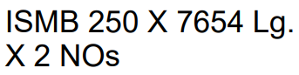

No Text Should be Present in this empty area in the drawing
Channels + Quantity format only allowed
ISMC (space) 300 (space) X (space) 8972 Lg (Next Line)
X (space) 1 (space) NO
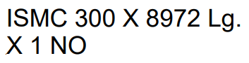
No Text Should be Present in this empty area in the drawing

ISMB, ISMC and X should be written in all in CAPITAL letters.
If the Quantity is 1 then also specify the quantity in the above format.
4. Plates should be written as
PLT (space) 150 (space) X (space) 82 (space) X (space) 8 (space) THK (Next Line)
X (space) 2NOS
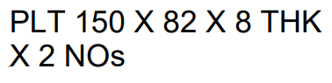
No Text Should be Present in this empty area in the drawing

5. Angle cleats should be written as
ISA (space) 100 (space) X (space) 100 (space) X (space) 10 (space) THK (Next Line)
250 (space) LG (space) X (space) 4 (space) Nos
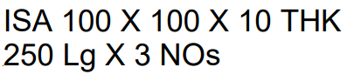
No Text Should be Present in this empty area in the drawing

6. Similarly, here also PLT, ISA, THK and X (capital X) all of them should be in UPPERCASE Alphabets. Lg (Capital L and small g).
7. DRG, SHEET, REV keywords should be present only once in the whole Drawing sheet.
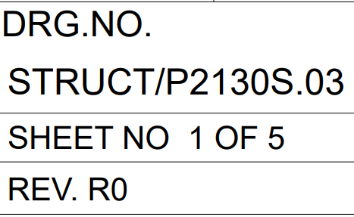
8. MKD values should start with a number, then contain alphabets and finally end with a number. Eg: - 4CEA6 MKD Values should not contain the alphabets S,O,I,L. No Spaces Should be Present in Between the mkd_values and coma when there are multiple mkd_values.
MKD (space) mkd_value (space) TO (space) mkd_value
